Class Diagram

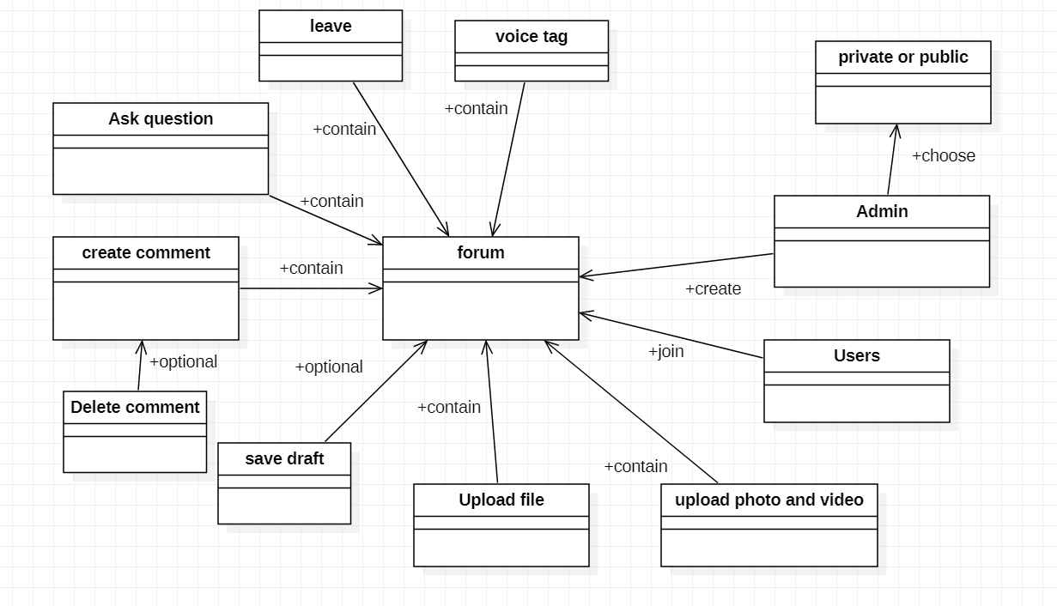

Class Responsibility

|  |  |
| --- | --- |
| Forum | |
| Upload photo and video |  |
| Upload file |  |
| Save draft |  |
| Create comment |  |
| Ask question |  |
| Leave forum |  |
| Upload Voice tag |  |
| Add users |  |
| User |  |
| Admin |  |

|  |  |
| --- | --- |
| Admin | |
| Admin id | Set as private or public |
| Admin name | Forum |
| Add users |  |
| Change forum name |  |
| Upload photo |  |
| Ask question |  |
| Upload file |  |
| Leave forum |  |
| Upload voice tag |  |
| Save draft |  |
| Create comment |  |

|  |  |
| --- | --- |
| User | |
| User name | Forum |
| User id |  |
| Join forum |  |
| Upload file |  |
| Upload photo and video |  |
| Upload voice tag |  |
| Ask question |  |
| Create comment |  |
| Leave forum |  |
| Save draft |  |

|  |  |
| --- | --- |
| Upload photo and videos | |
| photo | Forum |
| videos |  |
| Save draft |  |

|  |  |
| --- | --- |
| Upload file | |
| File date | Forum |
| File name |  |
| Save draft |  |
| Excel file |  |
| Word file |  |
| Pdf file |  |
| Python file |  |

|  |  |
| --- | --- |
| Save draft | |
| Save file as draft | Forum |
| Save photo and video as draft |  |
| Save voice tag as draft |  |
| Save comment as draft |  |

|  |  |
| --- | --- |
| Create comment | |
| Choose to upload file | Forum |
| Choose to upload voice tag | Delete comment |
| Choose to upload photo and videos |  |
| Save as draft |  |

|  |  |
| --- | --- |
| Ask question | |
| Choose to upload file | Forum |
| Choose to upload voice tag |  |
| Choose to upload photo and videos |  |
| Save as draft |  |

|  |  |
| --- | --- |
| Leave forum | |
| Delete data | Forum |
| Leave personally |  |
| admin |  |
| user |  |

|  |  |
| --- | --- |
| Voice tag | |
| Save as draft | Forum |
| Voice duration |  |

Design pattern

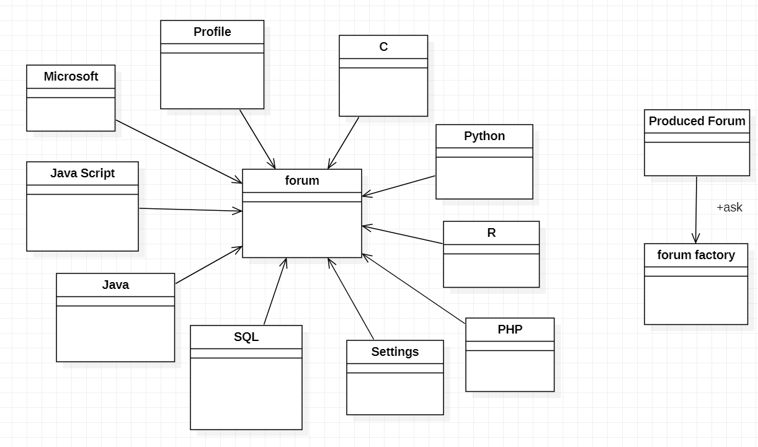

+create

The diagram above my programming forum system is choose the factory pattern as design pattern because factory pattern can create the object without reveal the creation logic to the users and refer to newly created object by using a common interface.Besides that, factory pattern is the best ways to create an object.

Abstract factory pattern has the responsible for creating a factory of the objects without specify the class.There is a example , the forum factory have produced many types of programming language ,some basic security system and profile information. In my diagram which is factory pattern that has generate the forum class like python,C,SQL and the other .